Project (1) [GEN211 Probability and Statistics]
Name \ Omar Ahmed Ramadan ID \ 240102684

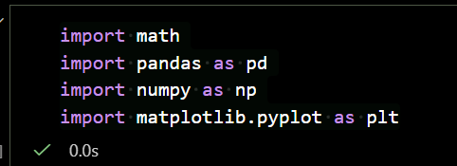
1- Import the necessary libraries to run the code.

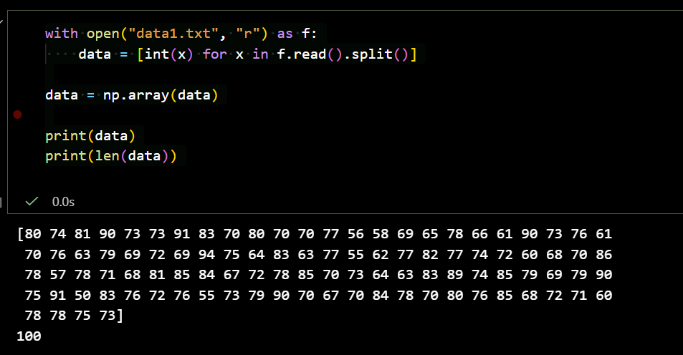
2 - Data Importing
The students’ scores are read from data1.txt and stored as integers in a NumPy array.
The total number of scores is printed to check that all data has been loaded correctly.

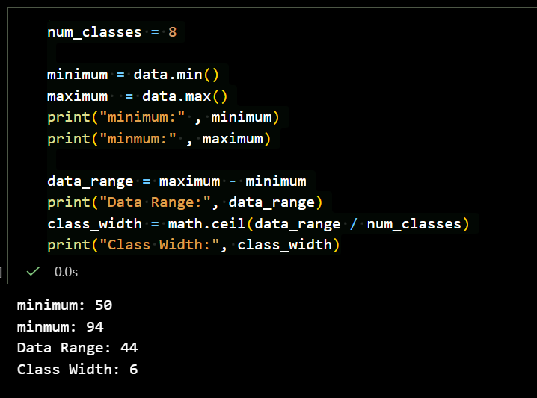
3 - Class Interval Calculation
The data is divided into 8 classes. The minimum and maximum values are identified to determine the range of scores.
The class width is calculated using the range divided by the number of classes, rounded up to ensure all scores fit within the intervals.

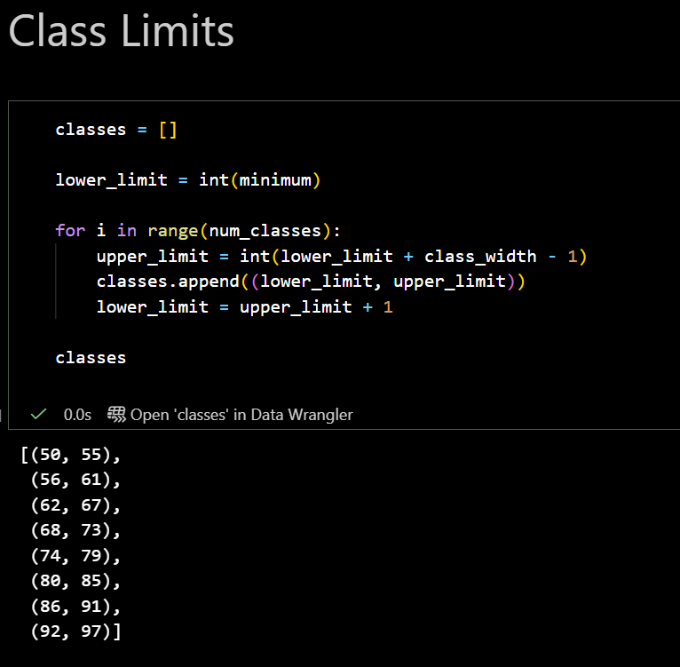
4 - Class Limits Construction
Class limits are created by starting from the minimum score and adding the class width for each of the 8 classes.
Each class is stored as a tuple of (lower limit, upper limit) to organize the data into intervals.

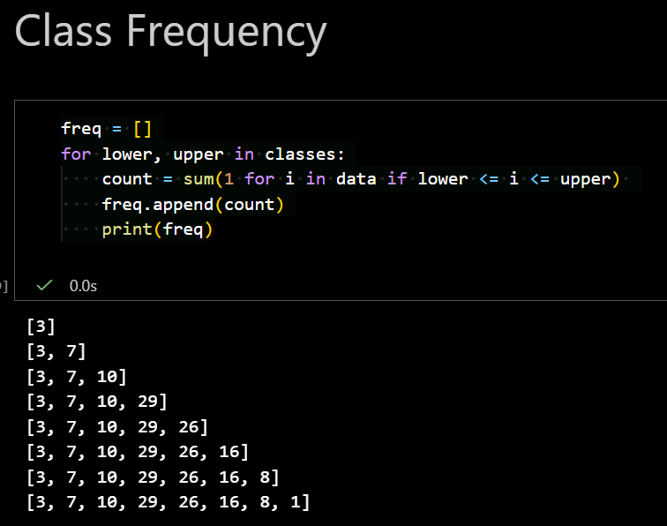
5 - Class Frequency Calculation
The frequency of each class is calculated by counting how many scores fall within each class interval.
This results in a list showing the number of students in each of the 8 classes.

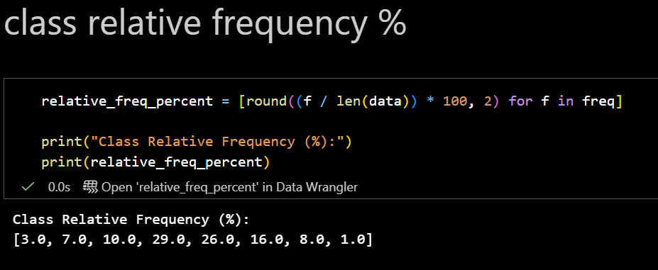
6 - Class Relative Frequency (%)
The relative frequency represents the percentage of students in each class compared to the total number of students.
It is calculated by dividing each class frequency by the total number of scores and multiplying by 100, then rounded to two decimal places.

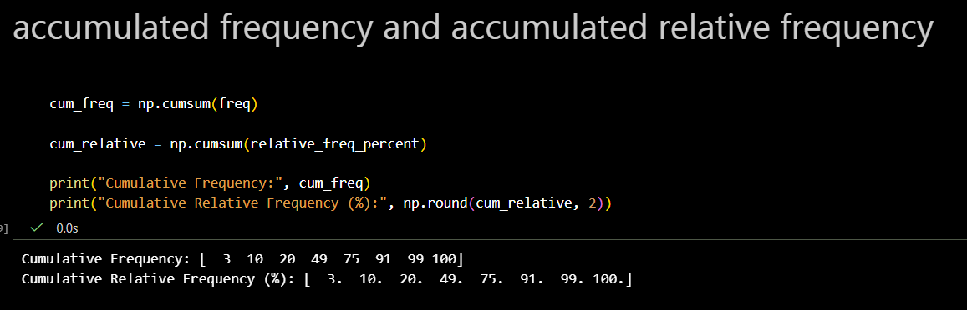
7 - Cumulative Frequency & Cumulative Relative Frequency
Cumulative frequency is the running total of frequencies up to each class, showing how many observations fall below the upper limit of that class.
Cumulative relative frequency (%) is the running total expressed as a percentage, which helps to see the proportion of data up to a certain class.
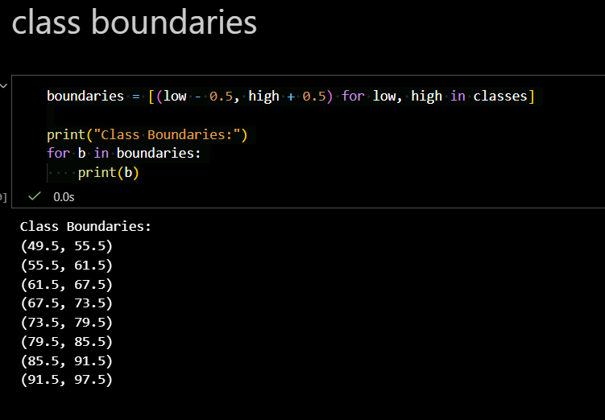
8 - Class Boundaries
Class boundaries are used to remove gaps between consecutive classes in a frequency distribution.
Each lower boundary is 0.5 less than the class lower limit, and each upper boundary is 0.5 more than the class upper limit.
This ensures a continuous range for plotting histograms or ogives.

9 - Histogram
This code plots a histogram of students' scores using the class limits as bin edges (boints).
- plt.hist() counts how many data points fall into each class (frequency).
- edgecolor="black" draws borders around each bar.
- plt.xticks(boints) ensures all class boundaries are shown on the x-axis.
It visually shows the distribution of scores, letting you see which ranges have more or fewer students
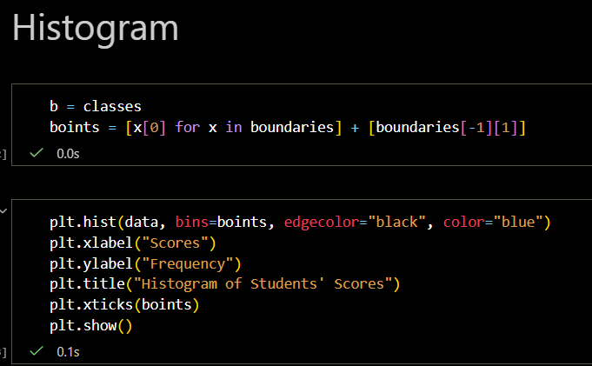
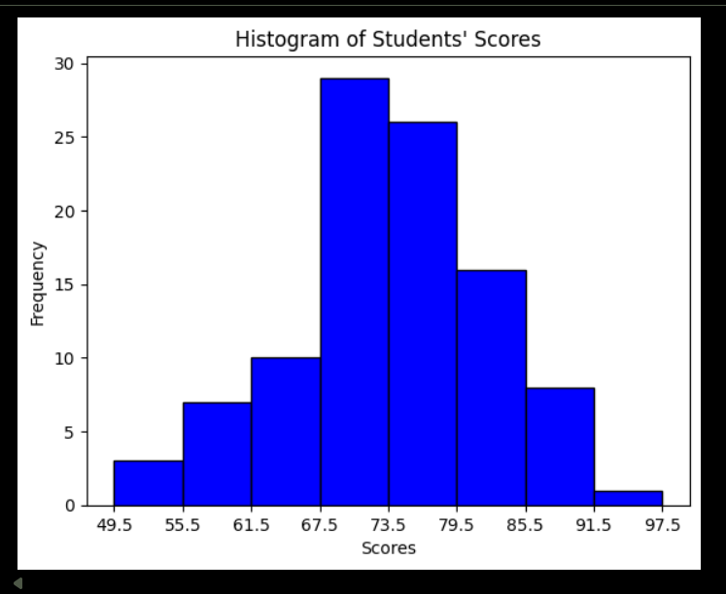
10 - Ogive (Cumulative Frequency Graph)
This code plots an ogive, which is a cumulative frequency graph.
x = [b[1] for b in boundaries] → uses the upper boundary of each class as the x-coordinate.
y = cum_freq → cumulative frequency values are plotted on the y-axis.
marker='o' → marks each cumulative point with a circle.
linestyle='-' → connects the points with a line.
plt.xticks(boints) → shows all class boundaries on the x-axis.
plt.yticks(range(0, len(data)+1, 5)) → sets y-axis ticks from 0 to total students, in steps of 5.
The ogive helps visualize how frequencies accumulate across classes, showing trends like the median or percentiles.
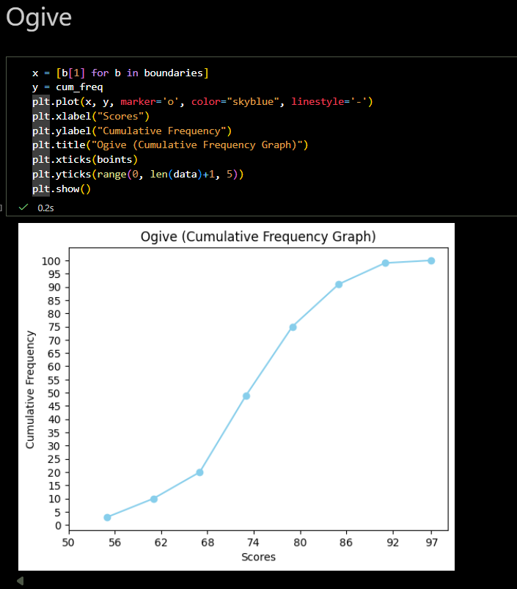
11 - Frequency Polygon
This code plots a frequency polygon, which is similar to a histogram but uses points connected by lines.
midpoints = [(m + n) / 2 for m, n in classes] → calculates the midpoint of each class, which represents the x-coordinate for each class.
freq → frequency of each class is plotted on the y-axis.
marker='o' → marks each point with a circle.
plt.plot(midpoints, freq, marker='o', color="blue") → draws the frequency polygon by connecting the midpoints with a line.
plt.xticks(midpoints) → shows all class midpoints on the x-axis.
plt.yticks(range(0, 20, 2)) → sets y-axis ticks for frequency values.
A frequency polygon clearly shows trends in frequency distribution and can be compared with other distributions more easily than histograms.
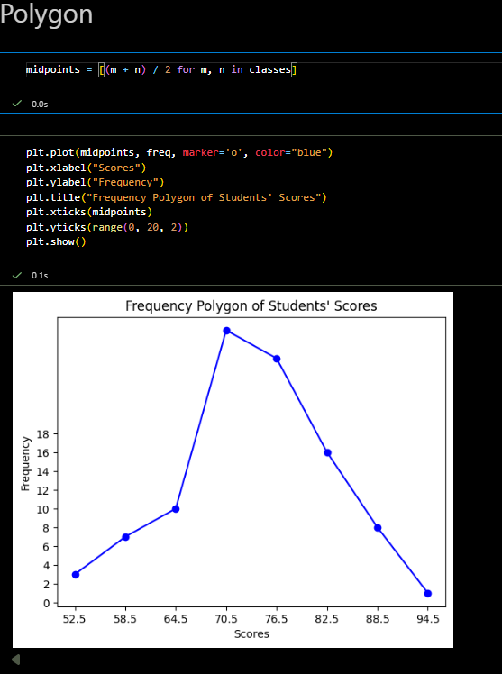
12 - Grouped Frequency Distribution Table
The code constructs a grouped frequency distribution table for the students’ scores imported from data1.txt.
Class Limits: Defines the range of scores for each class.
Class Boundaries: Slightly extended limits to avoid gaps between consecutive classes.
Midpoint: The average of each class’s lower and upper limits, used in plotting and calculations.
Frequency: Number of students in each class.
Relative Frequency (%): Percentage of students in each class relative to the total.
Cumulative Frequency: Running total of frequencies up to each class.
Cumulative Relative Frequency (%): Running total of relative frequencies, representing cumulative percentage.
The table provides a structured summary of the dataset, useful for visualization (histogram, frequency polygon, ogive) and further statistical analysis.

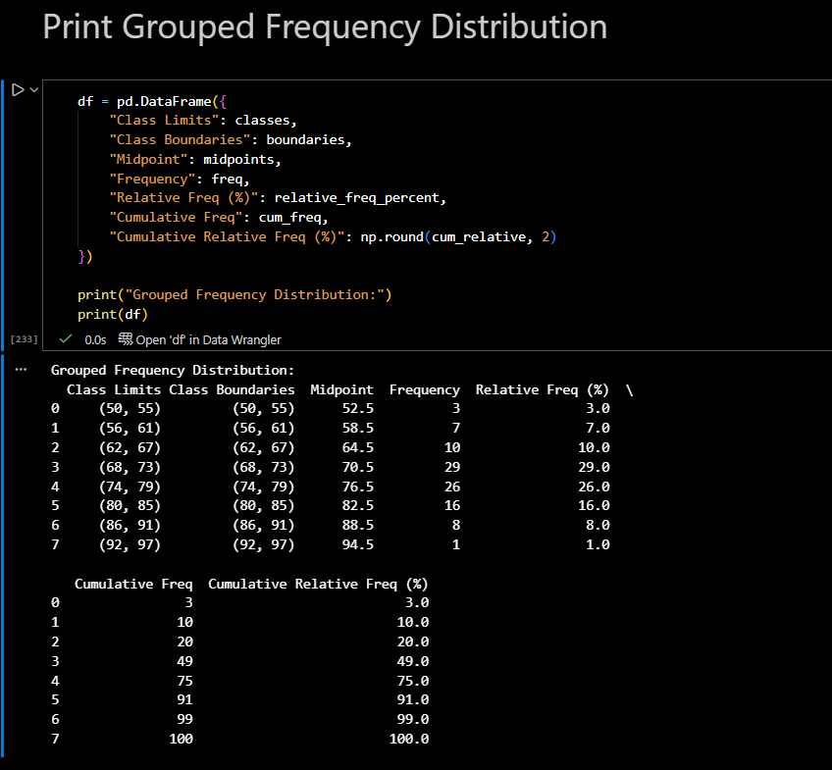
13 - Report: Raw Data Statistics
The code calculates descriptive statistics for the original raw data (all students’ scores):
- Mean: The average score of all students.
- Standard Deviation (SD): Measures the spread of scores around the mean.
- Coefficient of Variation (CV %): Expresses the standard deviation as a percentage of the mean, indicating relative variability.
These statistics provide insights into the central tendency and variability of the raw scores before grouping.

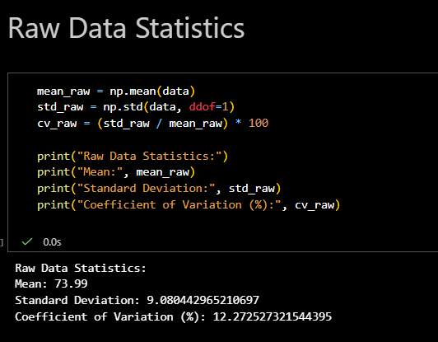

14 - Report: Grouped Data Statistics
The code computes descriptive statistics using the grouped frequency distribution:
- Mean: The weighted average of class midpoints, weighted by their frequencies.
- Standard Deviation (SD): Measures the spread of scores around the grouped mean.
- Coefficient of Variation (CV %): Shows relative variability of the grouped data as a percentage of the mean.
These statistics summarize the central tendency and dispersion after grouping the data into classes, giving an approximation of the raw data’s characteristics.

